Štefan Margita

Tenor

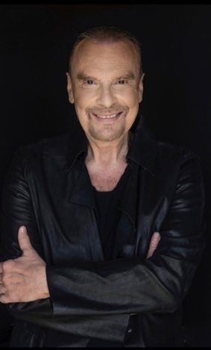
Among projects of Czech tenor Štefan Margita is Loge in concert performances of Das Rheingold in Dallas conducted by Fabio Luisi. Besides this several concerts are scheduled.
During recently seasons Štefan Margita gave three important role debuts: 2020 as Aegisth in Valencia, 2019 as Friedrich Wilhelm in Henze’s Der Prinz von Homburg in Stuttgart and 2018 as Captain Vere in Britten’s Billy Budd in Prague.

He was first acknowledged for his interpretation of Laca in Janáćek’s Jenůfa, a role he performed in almost all important opera houses in Europe and in Japan. Another signature role of his career war Kudriash in Katia Kabanova, 2017 he gave his debut in the Part of Tichon.

Patrice Chéreau’s new production of Janacek’s From the House of the Dead under Pierre Boulez made Luka / Filka Morozow became another important role of his career. He sang it also under Esa Pekka Salonen for his New York Metropolitan Opera debut in 2009, subsequently in Milan and Lisbon and under Simon Rattle at Staatsoper Berlin. He performed the same role in different productions in Palermo, Prague, Paris, London, Brussels and Lyon.

After his highly successful debut in the part of Loge in Wagner’s Das Rheingold 2008 under Donald Runnicles in San Francisco he was quickly invited to sing the same part again in San Francisco, at Metropolitan Opera under Fabio Luisi, 2012 in a new production at Bayerische Staatsoper under Kent Nagano and in Amsterdam under Hartmut Haenchen. He repeated the role 2013 in Munich, 2014 in Amsterdam and Houston, 2016 in Chicago and 2018 again in San Francisco.

Another signature role has become Shuiskij in Boris Godunov, he already performed 2011 at Chicago Lyric Opera, 2012 under Haenchen in Madrid and 2022 in Stuttgart.
But also Tambourmajor in Wozzeck, he performed in Paris, Rome and 2013 under Daniel Barenboim in Berlin, or Endrisi in Szymanowski’s Krol Roger are important roles of his current repertoire.
2014 he performed Valzacchi in a new production Der Rosenkavalier with Berlin Philharmonic Orchestra conducted by Sir Simon Rattle and staged by Brigitte Fassbender in Baden-Baden.

Štefan Margita was heard at the festivals of Salzburg, Ludwigsburg, Bregenz and Edinburgh as well as in the opera houses and on the concert stages of Stuttgart, Leipzig, Trieste, Dallas, London Madrid, Milan, Turin, Bergamo, Wien, Prague, Budapest, Berlin, Dresden, Frankfurt, Basel, Paris, São Paulo, Tokyo, Naples under conductors such as Gerd Albrecht, Semyon Bychkov, Aldo Ceccato, Lamberto Gardelli, Wolfgang Gönnenwein, Hartmut Haenchen, Janos Kulka, Sir Charles Mackerras, John Neschling, Antonio Pappano, Zoltan Pesko ...

His concert repertoire contains mainly pieces by Mozart, Beethoven, Dvorak, Mahler and Bartok.

07/2023

