Kudaibergen Abildin

Tenor

Kudaibergen Abildin was born in Kazakhstan. Since very young age, he was considered a highly gifted and perspective young musician with a huge passion for music.
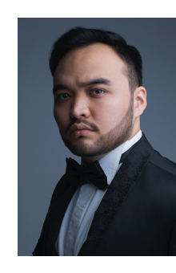
He graduated 2018 from the Kazakh National University of Arts (Nur-Sultan (Astana), made his Master's degree at the Conservatory of Music in Maastricht, the Netherlands in the class of Professor Axel Eiverart in Summer 2021. He continues his studies at the Mozarteum Conservatory in Salzburg, joining the postgraduate course class of Professor Mario Diaz.

Quickly building international solo career at his young age, Kudaibergen is a laureate of numerous international music competitions in his home counrty and also abroad. Some of these competitions are: International Vocal Antonín Dvořák Competition: second prize at the Karlovy Vary, Czech Republic, 2016; third prize at the International Vocal Bibigul Tulegenova Competition in Nur- Sultan, Astana, 2017; International Vocal B. Shtokolov Competition: Second prize in Saint- Petersburg, and the Special Prize for the best interpretation of a Shtokolov’s romance, 2018. He was awarded the Eva Rondova Award for the interpretation of the aria “Che Gelida Manina”. 2019; Diploma winner at the Rita Gorr competition (Ghent, Belgium), 2021; Diploma winner of the Obraztsova competition (St. Petersburg, Russia)
Being one of the most promising young musicians of his generation, Kudaibergen Abildin collaborated and shared the stage with many world-class famous artists.

Continuously mastering the art of solo opera performance, Kudaibergen has been a participant of numerous master-classes where he had the honour and the pleasure to work with such outstanding teachers like Sergei Leiferkus, Tatiana Smelkova, Barbara Haveman. and many others.

Known for his rigorous programming and dedication to the classic and romantic repertoire, Kudaibergen Abildin has given solo and chamber music concerts in Kazakhstan and Europe: in The Netherlands, Czech Republic, Belgium and Russia.

12/2021

