Evgeniya Sotnikova

Soprano

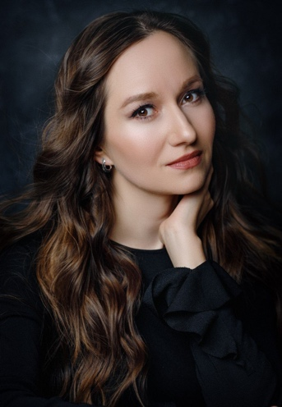
Evgeniya Sotnikova was born in Russia (Kurgan). She studied at the Rimsky-Korsakov State Conservatory in St. Petersburg and was a prizewinner in many competitions. After she performed the title role in Tchaikovsky’s Iolanta in the Opera and Ballet Theatre under the St.Petersburg Conservatory.
In the same year, Evgeniya Sotnikova joined The Kolobov Novaya Opera Theatre in Moscow, where she sang the part of Tatyana in Tchaikovsky's Eugene Onegin.
In 2009 she was awarded the special Oscar und Vera Ritter-Stiftung Prize at the International Singing Contest of Italian Opera in Dresden. This led to her joining the opera studio of the Bayerische Staatsoper in Munich, going on to join the Ensemble of the Bayerische Staatsoper.
She went on to make her UK debut with the Glyndebourne Touring Company, singing the role of First Wood Sprite in Rusalka, following this with Ilia in Idomeneo, Leïla in Les Pêcheurs de Perles and Soeur Constance in Les Dialogues des Carmélites for the Stadttheater Klagenfurt.
At the Zurich Tonhalle, she sang Stravinsky’s Les Noces, conducted by David Zinman and made a most successful return to the Bayerische Staatsoper as Jemmy in Guillaume Tell, for which she was awarded the Festspiel Preis 2014.
She sang at the Ruhrtriennale and at the New York’s Armory Hall the part of Hadewijch in Louis Andriessen’s De Materie and the title role of Rimsky-Korsakov’s Snow Maiden for the Estonian National Opera.
She made her Italian debut in Stravinsky’s Les Noces with the Accademia di Santa Cecilia, conducted by Pablo-Heras Casado.
She performed Contessa in Le Nozze di Figaro in concerts at the Copenhagen Opera Festival and at the Malmöfestivalen and then repeated the role in a staged production for the Malmö Opera and for Estonian National Opera.
She made her debut in Hamburg State Opera as Jemmy. And returned to Munich in 2017 for Jemmy and 1st Nymph again.
Evgeniya made her debut at Elbphilharmonie Hamburg in Silvesterkonzert with Kent Nagano, later she sang in Beethoven’s 9th Symphony with Symphony Orchestra Innsbruck.
In 2018 Evgeniya made her debut as Despina in Così fan tutte at the Bolshoi Theater and sang part of Aleya in a new production of Janacek's From the House of Dead in Munich.
In 2020 she sang fragments from the opera Der Rosenkavalier (part of Sophie) at Tchaikovsky
Concert Hall with Svetlanov Symphony Orchestra and Vladimir Jurowski, 2022 sang in the world premiere of the opera The end of creation by Bernhard Lang in Augsburg and guested in Berne as Gemmy in Guillaume Tell.

She worked with conductors such as Kirill Petrenko, Andris Nelsons, Peter Rundel, Kent Nagano, Thomas Hengelbrock, Asher Fisch, Paolo Carignani, Constantinos Carydis, Karel Mark Chichon, Dan Ettinger, Stefan Soltesz, Pablo-Heras Casado, Simone Young, Vladimir Jurowski and with such stage directors as: Árpád Schilling, Antú Romero Nunes, Martin Kušej, Heiner Goebbels, Richard Brunnel and Peter Stein.
07/2023

